2.C Education and Workforce Development
The national transportation system relies on a highly skilled and qualified workforce, but a number of challenges face transportation agencies in attracting, educating, and retaining skilled workers and professionals, including
- Over half the current workforce is projected to retire within 10 years, and heavy competition from other fields complicates attracting/retaining qualified workers.
- Transportation careers are largely invisible to youth; attracting and integrating women and minorities, in particular, remains challenging.
- New technologies and more complex systems require additional skills within traditional engineering, as well as skillsets in other disciplines.
In other words, the “education” mission of UTCs has expanded to a more complex mission: “workforce development.” To get a better handle on this reality, a series of regional summits sponsored by CUTC were held to identify national transportation workforce needs and set goals/strategies/best practices to address those needs across various transportation career paths; the regional events culminated in a National Transportation Workforce Summit (NTWS). InTrans hosted the upper Midwest summit and was a sponsor of the national summit with team members serving on the steering and planning committees.
Using knowledge gained from the summits and the team’s own expertise, the MTC’s workforce development plan will leverage existing partnerships and programs that have proven successful and develop new collaborations to avoid overlap and share
resources to meet the following objectives: 1) encourage new entrants to the field
(K–12); 2) enhance the formal, post-secondary education of the next generation; and 3) support life-long learning and retraining and reentry of mid-career workers.
Each of the following sections describes the proposed activities and related experience for a specific level. (Several activities in Leadership, Tech Transfer, and Diversity chapters of this proposal are also relevant to workforce development.)

2.C.1. Encouraging New Entrants
By high school, young people have selected educational paths that will determine their preparedness for college and careers. Because children, parents, and often educators are largely unaware of transportation careers, it is important to reach out early and in a variety of ways to catch and hold their imagination. The MTC is well positioned to do so, based on its leadership of numerous activities:

Transportation Outreach Kits. Five portable outreach kits, each examining a different aspect of transportation will be developed and will include background information about the topic, a description of the activity, a summary of related careers, and hands-on activities. MTC will train graduate and undergraduate peer mentors to guide K–12 students and/or teachers through the kit materials. MTC will work with several existing programs, such as MU’s and ISU’s PWSE, which hosts workshops to help teachers implement STEM lesson plans in their classrooms; ISU’s Road Less Traveled conference (described in Section 2.G); Science Bound; and 4-H. Using these connections, we anticipate reaching more than 5,000 students annually.
Enhancement of Go! MTC’s support of the e-zine, Go!, will be used to (a) develop 18+ articles, (b) interview 4+ role models with unique jobs (for example, Go! interviewed trucker Lisa Kelly from the History Channel’s Ice Road Truckers), (c) increase visitors by 10 percent through social media and marketing, (d) develop an internship program for journalism and marketing majors, and (e) collaborate with other UTCs (e.g., the team collaborated with the University of Vermont’s National Summer Transportation Institute where students blogged and discussed their experiences). We hope to increase the annual number of unique visitors to over 15,500.
http://www.go-explore-trans.org/
Partners can contribute articles, do a blog, offer to help edit student work

Expand Curriculum Connections. Go! will work with each partner to develop Curriculum Connections based on its research expertise. Each module will include (a) background, (b) tasks for interactive learning, (c) resources, (d) evaluation rubrics, (e) teacher notes, and (f) links to related transportation careers. The team will also coordinate with the TWT course to develop 6+ interdisciplinary modules.
http://www.go-explore-trans.org/category/features/curriculum-connection/
Partners can develop curriculum connections

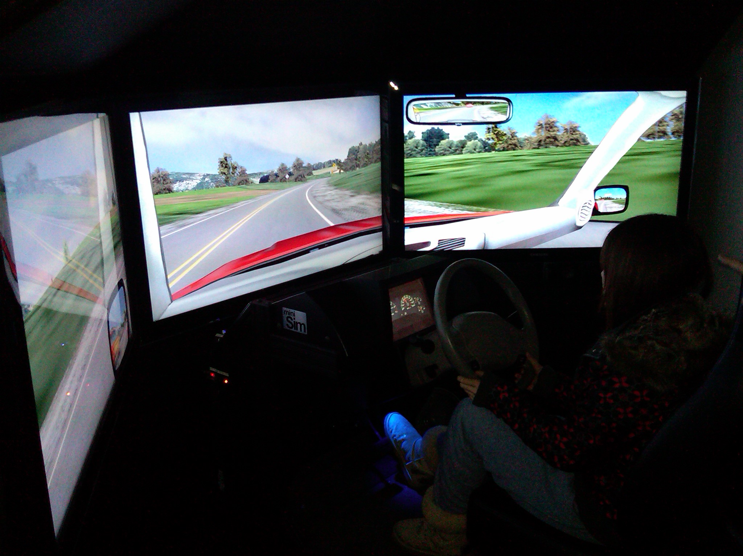
Distracted Driving Workshops. MTC will work with the University of Iowa’s National Advanced Driving Simulator team to develop distracted driving simulator scenarios that will be incorporated in the
InTrans mobile driving simulator. Activities will be designed to educate teens about the dangers of distracted driving and introduce them to careers in safety engineering, vehicle design, and policy. This will build on a workshop developed by InTrans for 4-H clubs that attracted 120 students. Workshops will be held at public libraries, youth clubs, 4-H, and driver education programs in partnership with the Iowa Governor’s Traffic Safety Bureau, with the goal of reaching 500 students. Data from workshop simulator drives will be evaluated for use in research, education, and outreach activities.
Summer research institutes
ISU is currently working with another engineering group to host RET

2.C.2. Enhancing Post-Secondary Education
Developing “human capital” involves optimizing students’ academic preparation for professional careers in transportation. MTC partners have a rich history of educating engineering students. ISU, one of the first land grant universities, had a civil engineering program by 1871, and its first dean of engineering was the first chair of what is now the Transportation Research Board. Currently, ISU’s College of Engineering offers 13 undergraduate and nine graduate majors to more than 4,200 students and is 12th largest nationally in undergraduate engineering enrollment. Further, over the past few decades ISU has developed similar strengths in Business, Logistics, and Supply Chain Management. MU, the oldest public university west of the Mississippi River, serves as the land grant and research university in Missouri and is nationally recognized for its cross-disciplinary collaborative teaching and research.
Collaborative Internship Partnership. Experiential education provides real-world
context to students, which is important for connecting educational concepts to professional practice. MTC will build on a pilot mentoring program being developed by InTrans and the Iowa DOT. It involves practitioners mentoring students in work settings, and faculty members working with practitioners, to help students relate their academic work to career activities. The partnership will also draw on the success of an MU engineering model for collaboration with industry. Internet based tools will be used to support participant interactions to highlight success and lessons learned so others can develop similar partnerships. The Asphalt Materials and Pavements Program collaborates with the Asphalt Paving Industry in selection and placement of summer interns with more than 70 applicants for 15 positions for the 2013 Summer- this program will be enhanced and broadened to include all areas of the MTC. Approximately 80 undergraduate students in civil engineering, accounting, industrial technology, and marketing will be served annually.
Undergraduate Research Groups. Many careers require education beyond the bachelor’s degree. However, encouraging domestic students to pursue advanced degrees is challenging when students are able to obtain relatively well paying careers with a bachelor’s degree. To attract qualified students to graduate studies, MTC will establish a program to engage undergraduate students in research enterprise with interested faculty. MTC will leverage the networks and resources provided at ISU, such as the Undergraduate Research Assistantship program which provides 60 percent of the funding to support qualified undergraduate students to work with faculty on research efforts. Graduate students will be encouraged to serve as peer-mentors. MTC will draw on the experience of MU, which has developed an undergraduate research program with over 100 undergraduates. Approximately 40 undergraduate students will be served annually; particular emphasis will be placed on recruiting female and minority students.
Transportation Seminar. MTC will provide resources to continue hosting the weekly Tom Maze Transportation Seminar. The seminar hosts speakers from around the country, providing students with a broad picture of transportation issues. Seven universities within Region 7 are participating this spring (ISU, Kansas State, University of Kansas, University of Iowa, University of Nebraska, MU, and UMSL). Professional staff from state DOTs and the FHWA division offices also regularly attend. The seminar is web-based so new partners can participate and host speakers from their own institutions. Topics will focus on the MTC theme, and students enrolled in the course for credit will participate in outreach activities for K–12 (described earlier). About 84 students per semester are involved.
Transportation Scholars Program. The MTC Transportation Scholars program was cited by RITA in its 2009 UTC Program Points of Pride. Although originally geared to graduate students, undergraduate students will be encouraged to participate. About 20 undergraduates and 80 graduate students will be included. Requirements for the program will be adjusted to include more active participation and a leadership component, as follows:
- Maintenance of a 3.0 grade point average.
- Participation in a research project or research group.
- Attendance at the weekly transportation seminars each spring semester.
- Participation in the annual student research paper/poster contest.
- Mentorship of other students or participation in K–12 outreach activities.
- Presentation of research results at a conference or through a journal article.
- Participation in the Leadership Institute (see Section 2.B.2).
- Participation in one or more transportation student organizations.
Short Summer Session Study Abroad

2.C.3. Supporting Working Professionals and Second Careers in
Transportation
Life-long learning is becoming increasingly important to practitioners in transportation enabling them to develop their knowledge, skills, abilities and competencies in rapidly changing fields, and also to facilitate career growth and transition. Such opportunities will also help individuals transition to new and 2nd careers in transportation. The MTC will address such needs through formal and informal educational offerings: degree and certificate programs, professional development activities, and technology transfer activities (see Section 2.D). Activities align with several strategies suggested by NTWS, including identifying and marketing positions with broad, transferable skill requirements and providing mid-career training.
Develop a Certificate Program in Transportation. By building on existing ISU programs and partnering with other universities and professional organizations, MTC will develop a graduate certificate in transportation. Examples of such resources and collaborations include existing Department of Civil and Construction’s certificates such as construction management, and the Transportation Leadership Graduate Certificate program led by North Dakota State University. The certificate will provide practitioners with non-degree seeking opportunities for professional development through a required 12 credits in one of the following focus areas. About 10 to 15 students per year are expected to enroll.
- Safety. CE 552: Traffic Safety; CE 556: Transportation Data Analysis; CE 558: Transportation System Management; and one statistics course.
- Asset management. CE 556; CE 558; CE 559: Transportation Infrastructure/Asset Management; and one business/project management course.
- General Transportation: Three transportation courses and one other relevant course.
Expand Interdisciplinary Master’s Degree. Many non-engineering practitioners find they are in fields where opportunities are stagnant and are looking for other opportunities. ISU offers an interdisciplinary MS degree in Transportation where students matriculate through engineering, Community and Regional Planning (College of Design), or Logistics, Operations, and Management Information Systems (College of Business). The interdisciplinary MS in Transportation provides an opportunity for practitioners to re-matriculate into a transportation-related career without having to re-do a bachelor’s
degree. The current MS in Transportation will be updated to include additional focus
areas. For instance, a joint program with Computer Science provides the backbone for a track in Intelligent Transportation Systems; a joint program with Agricultural Economics (MU) provides a focus in risk assessment. Students within each track will take a set of core classes and work with an advisor to develop a cohesive curriculum to meet career objectives—an ideal mechanism for professionals with bachelor’s degrees to train for a career in transportation. We plan to include eight to ten students per year.

2.C.4 Performance Measures for Workforce Development Activities
A work plan will be developed for each activity outlining the specific performance measures to be tracked and data collection intervals for those measures. Additionally when appropriate, feedback will be sought from participants (i.e., students would be asked about whether they were more likely to consider a career in transportation).
Objective | Performance Metric | Source
Encourage new entrants | - Number of workshops/activities  - Students enrolled (diverse students)  - New and returning visitors to web pages  - Facebook and Twitter followers  - Number of schools participating | - Publications staff will track  information from web pages  - Education coordinator will gather information from annual updated resumes  - Activity leaders will report  after each activity
Enhance post-secondary education | - Number of courses/workshops  - Students enrolled (diverse students)  - Number of schools participating  - Faculty participating  - Number of students serving as peer mentors
Support practitioners and assist with retraining/ reentry

